Curtis J. Bonk, Indiana University, School of Education
Instructional Systems Technology (IST) Department
Shortest Bio

Shortest Bio:
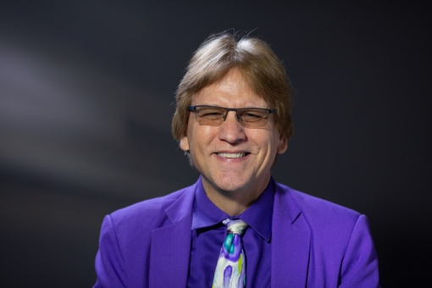
Curtis J. Bonk is a professor at Indiana University Bloomington who specializes in research on nontraditional and informal learning at the intersection of psychology, technology, education, and business. Self-described as part accountant, part educational psychologist, part digital learning technologist, part global educator, part writer, part inspirational speaker, part creative pedagogist, part maverick, and part entrepreneur. You can contact him at cjbonk@indiana.edu or http://curtbonk.com/.

